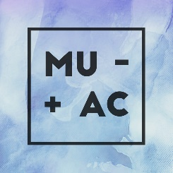

MacEwan University Accounting Club
- network. educate. empower. -

NOVEMBER 2018 NEWSLETTER

November 23, 2018

A successful MUAC Bake Sale!
The MUAC Bake Sale was held on November 5 & 6 by the SAM Centre at Building 6 of MacEwan University. Some of the tasty treats included are brownies, cupcakes, cookies, banana bread, muffins, and ginger snaps. We have raised $460.35 from the bake sale and all proceeds will be donated to the Students’ Association of MacEwan University Food Bank.
- For more info on SAMU Student Food Bank, visit samu.ca/programs-services/foodbank
Our team would like to send our huge thanks to all who came to support and donated for our baked sale and for entering the raffle draw to win an Oilers tickets!


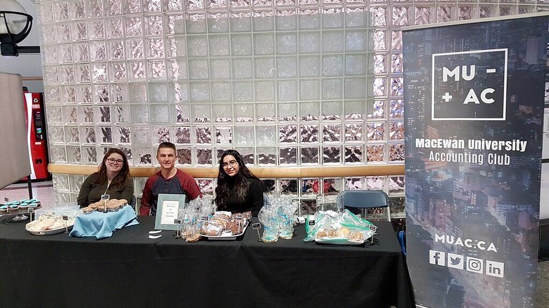

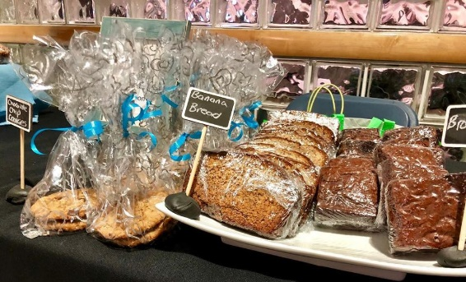
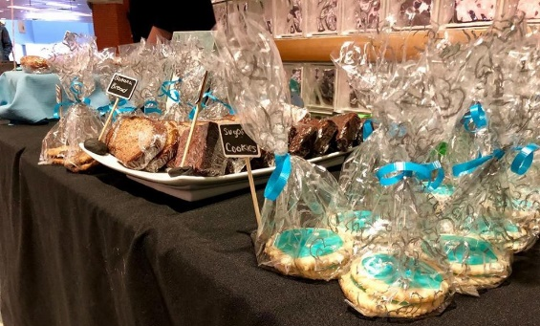

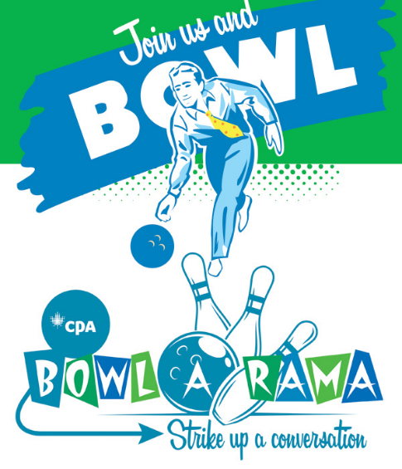
Next CPA Event: Bowl-A-Rama!
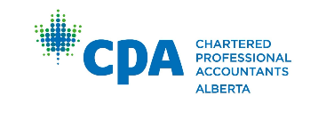
January 29th - Bowl-a-Rama
an exclusive evening of bowling and networking with local CPAs. Stay tuned for more details!


MUAC Tax Clinic 2019 Updates

Our tax clinic is soon approaching so keep your eyes open and stay tuned for amazing volunteer opportunities!

Thank you for reading our newsletter and look out on our social media accounts and newsletter emails for amazing volunteer and fundraising opportunities happening soon!

Have a great day and best of luck on your studies!

Cheers,
Your MUAC Executive Team

